

**Lab Manual- Create Azure Virtual Network and Bastion**

**Prepared for**:

**Date:** 18th Nov 2023

**Prepared by:**

Document Name: Lab Manual **Document Number** AZLab999

**Contributor:**

Contents

1. Introduction 3

2. Lab Create Azure Virtual Network 3

1. Create Primary Network 3

2. Create Two Secondary Network 7

3. Deploy Bastion Subnet 8

3. Lab Create Azure Virtual Machine 9

4. Lab Create Peering Between US and India 14

5. Lab Access VM with Bastion 15

## Introduction

The objective of this lab is to **design and implement a secure and connected Azure network architecture** using a **Hub-Spoke topology**.

Participants will learn how to configure **multiple VNets**, establish **connectivity via peering**, and securely access virtual machines using **Azure Bastion** without exposing public IPs.

After completing this lab, you will be able to:

* Design a **Hub-Spoke network topology** in Azure.
* Configure **VNet peering** for controlled inter-network communication.
* Deploy and use **Azure Bastion** for secure remote access.
* Create and manage **VMs across multiple subnets**.
* Troubleshoot **connectivity and NSG/firewall configurations** effectively.

## Lab Create Azure Virtual Network

### Create Primary Network

* Login to Azure and Search **Virtual Network**

* Click **Create** to Create the Virtual Network

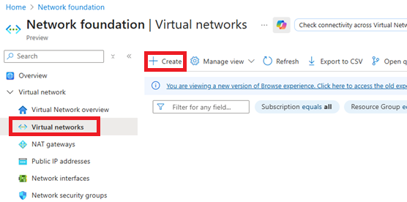

* Fill Following Details
  + 1. **Resource Group :** ODL-AZ-XXX
    2. **Name:** US-Vnet
    3. **Location:** WestUS2

* Click **Next** Twice to **IP Address** and Delete the **Default Subnet**

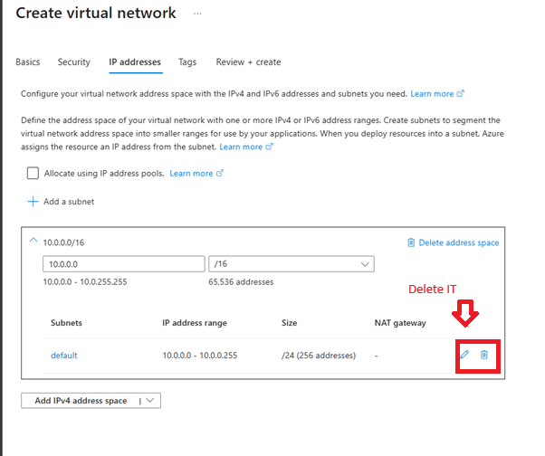

* Chang the IP Schema from **10.0.0.0** to **10.1.0.0** and Click **Add a Subnet**

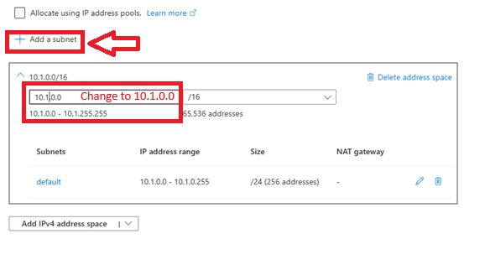

* Change In the Subnet fill the following Details and Click **ADD**
  + 1. **Subnet Name :** US-FE
    2. **IP:** 10.1.1.0

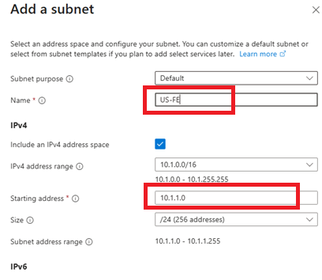

* Repeat the process and create another subnet. In the Second Subnet fill the following Details and Click **ADD**
  + 1. **Subnet Name :** US-BE
    2. **IP:** 10.1.2.0
    3. **Subnet Delegation :** SQL Server Managed Instance

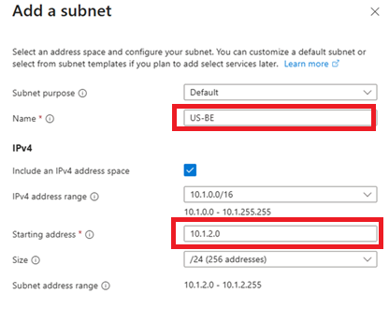

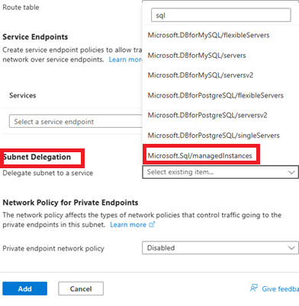

* Click **Review + Create** 🡪 **Create**

### Create Two Secondary Network

* Create India VNet With Following Details
  + 1. VNet Name = IN-VNet
    2. Location : WestUS2

India VNet Subnet

* + 1. IP Schema : 10.2.0.0
    2. **Subnet Name :** US-FE
    3. **IP:** 10.2.1.0
    4. **Subnet Name :** US-BE
    5. **IP:** 10.2.2.0

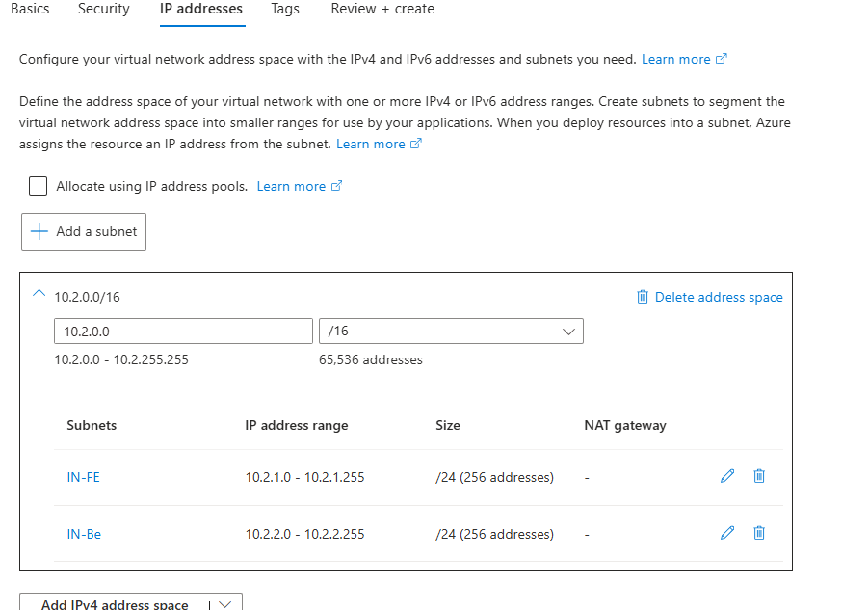

* Create Singapore VNet With Following Details
  + 1. VNet Name : SG-VNet
    2. Location : WestUS2

India VNet Subnet

* + 1. IP Schema : 10.3.0.0
    2. **Subnet Name :** SG-FE
    3. **IP:** 10.3.1.0
    4. **Subnet Name :** SG-BE
    5. **IP:** 10.3.2.0

### Deploy Bastion Subnet

* Go to the **US VNet** and Under **Setting** Click **Bastion** and Click **Deploy Bastion**

* Deployment May Take 25 Min to 45 Min so Procced to net Lab . Once Your Deployment Finish this is how you can see the next screen

## Lab Create Azure Virtual Machine

In This Step we will deploy 3 VM Two in US FE and One in SG FF.

#### First Virtual Machine

* In The Azure Search , Type **Virtual Machine** and select it

* In The **Virtual Machine** , Fill the Basic Details and Click Next

**Subscription :** ODL-AZ-XXXX

**VMName :** IN-VM-01

**Region :**  WestUS2

**Availability Option :** No Infrastructure redundancy required

**Security type :**  Standard

**Image :** Window Server 2019 Datacenter – x64 Gen2

**Size :** IN-VM-01

**Region :** Standard_DS1_V2 – 1 CPU , 3.5 GiB Memory

**UserName :** Vmadmin

**Password :** Password@123

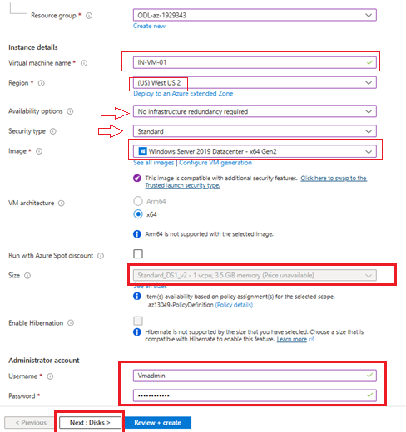

* In The Next Screen **( Disk )** Select **Standard HDD** and Click Next

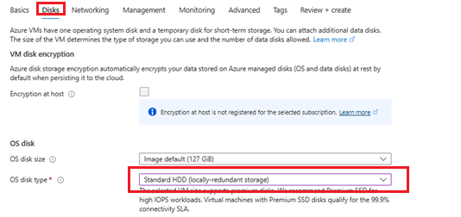

* In The **Network** Section Select **IN-VNet** and **IN-FE**

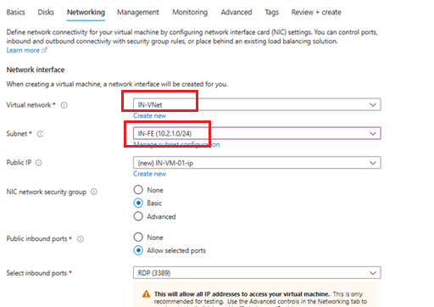

* Click **Review + Create** 🡪 **Create**

#### Second Virtual Machine in Indian-VNet

**Basic**

**Disk**

**Network**

#### Thirds Virtual Machine in Singapore-VNet

In The Singapore **VM Create VM in Backend ( SG-BE** ) and There is No Public IP in the network

**Basic Screen**

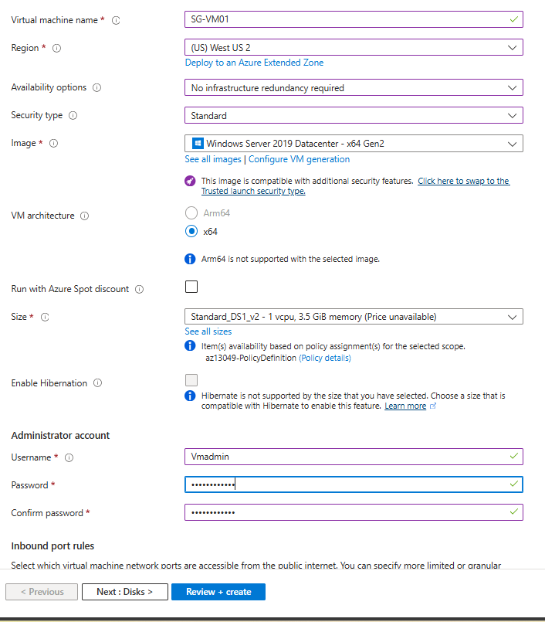

**Disk Screen**

**Network Screen**

Make Sure to Select None in Public IP

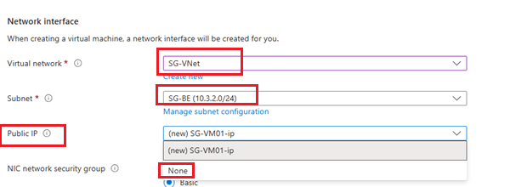

## Lab Create Peering Between US and India

* Go To US Vnet 🡪 Setting 🡪 Peering and Click **Add**

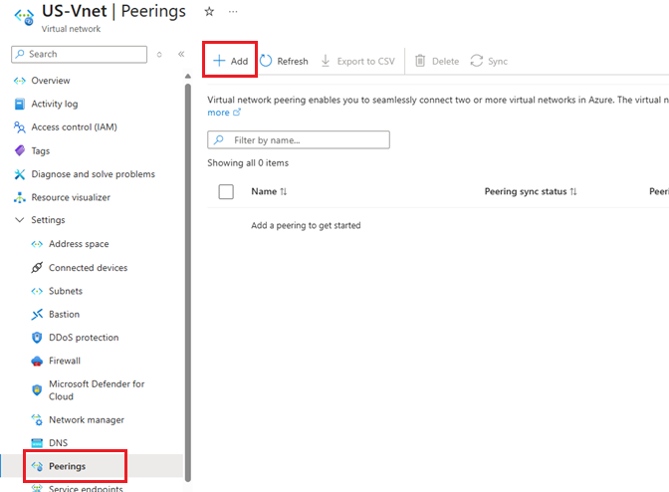

* Configure Details as Below

**Remote virtual network summary**

**Peering link name** : US-To-IN

**Remote Virtual Network** : IN-Vnet

**Allow 'IN-VNet' to access 'US-Vnet'** : Check

**Allow 'IN-VNet' to receive forwarded traffic from 'US-Vnet :** Check

**Local virtual network summary**

**Peering link name** : IN-to-US

**Allow 'US-VNet' to access 'US-Vnet'** : Check

**Allow 'US-VNet' to receive forwarded traffic from 'US-Vnet :** Check

* Click Add

## Lab Access VM with Bastion

Connect all 3 VM with Bsstion

* Go to VM 🡪 Overview 🡪 Connect 🡪 Connect Via Bastion

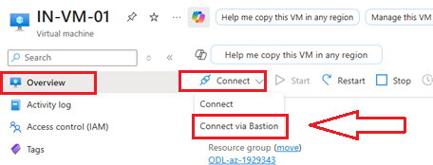

* Provide Username **VMadmin** and Password **Password@123** and Click **Connect**

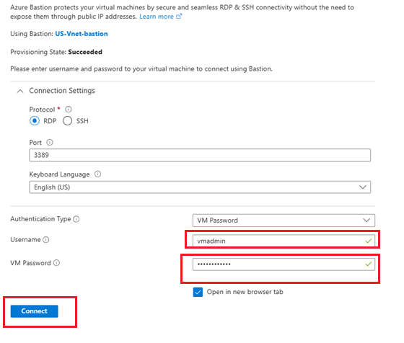

* If popup come 🡪 click **Allow**

* Now Open **PowerShell** in **Admin Mode**

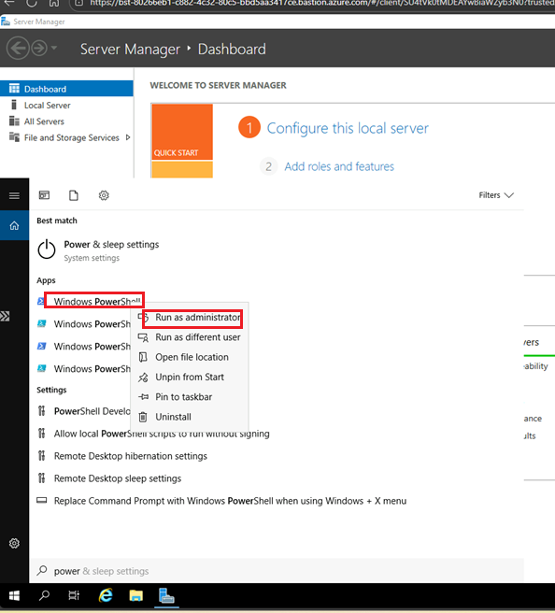

* Type below command

**Enable-NetFirewallRule -Displ**ayGroup "Remote Desktop"

**Enable-NetFirewallRule -DisplayGroup "File and Printer Sharing"**



* Now Repeat it with Second India VM

Test The If both VM is ping to each other on Private IP

